Customer Switching Report for the Electricity and Gas Retail Markets
1st January 2016 – 29th February 2016

DOCUMENT TYPE: | Information Note
REFERENCE: | CER/16122
DATE PUBLISHED: | 12th April 2016
QUERIES TO: | Gina Kelly  gkelly@cer.ie

The Commission for Energy Regulation,
The Exchange,
Belgard Square North,
Tallaght,
Dublin 24.
www.cer.ie

CER – Information Page
Overview
This report presents information on the number of customers switching supplier between January 2016 and February 2016 in the electricity and gas retail markets.
The report shows that for the month of February 2016 switching increased compared to February 2015.
The report covers customer gains, customer losses and the net switching rate for all suppliers with a market share of greater than 1% for domestic and business customer switches completed in a given month. All data excludes new registrations as they do not involve a switch from one supplier to another.
In February the total number of switches in the electricity sector, was 28,684 and in the gas sector, the total number of switches for the month was 8,766.

Target Audience:
Electricity Suppliers, Electricity and Gas Customers, Potential New Entrants.

Purpose of this Paper
The purpose of this paper is to report the level of switching in both the electricity and gas retail markets. This data is used internally by the CER in its ongoing retail market monitoring activities and should be of interest not only to electricity and gas customers and suppliers but also those considering entering the gas and electricity retail markets.
This report compliments the more detailed retail market reports published by the CER; such as the CER’s quarterly and annual retail reports (see here). This switching report will be published monthly.

For further information on this report, please contact Gina Kelly gkelly@cer.ie

Table of Contents
Purpose of this Paper 4
1 Customer Switching in the Electricity Retail Markets 7
1.1 Completed Electricity Switches per Month 7
1.2 Suppliers’ Net Switching Position 8
1.3 Suppliers’ Gains and Losses 10
2 Customer Switching in the Gas Retail Markets 12
2.1 Completed Gas Switches per Month 12
2.2 Suppliers’ Net Switching Position 13
2.3 Suppliers’ Gains and Losses 15

List of Figures

Figure 1. The total number of electricity customer switches completed per month from January 2010 to February 2016. 5

Figure 2. The net switching position of each electricity supplier from January 2010 to February 2016, for domestic and business customers. 6

Figure 3. The net switching position of each electricity supplier from February 2015 to February 2016, for domestic and business customers. 7

Figure 4. The total number of gas customer switches completed per month from January 2010 to February 2016. 10

Figure 5. The net switching position of each gas supplier from January 2010 to February 2016, for domestic and business customers 11

Figure 6. The net switching position of each gas supplier from February 2015 to February 2016 for domestic and business customers. 12

List of Tables

Table 1. Monthly customer losses by electricity supplier. 8
Table 2. Monthly customer gains by electricity supplier. 9
Table 3. Monthly customer losses by gas supplier. 13
Table 4 Monthly customer gains by gas supplier. 14

Customer Switching in the Electricity Retail Markets
This section provides monthly data for the electricity retail markets. The report covers switching from January 2016 to February 2016 and includes;
- Total completed switches
- Suppliers’ net switching position (this shows whether or not a supplier is winning more customers than it is losing in a given month)
- The number of customers switching to each supplier
- The number of customers moving away from each supplier
The data includes all switches completed by domestic and business customers. The data excludes new registrations as these customers have not switched from one supplier to another.
Where data is presented per supplier, only suppliers with a 1 % market share (on a consumption basis) or greater are presented – based on data from the most recent retail quarterly report.

Completed Electricity Switches per Month
Figure 1 details the total number of completed electricity switches in each month from January 2010 to February 2016.
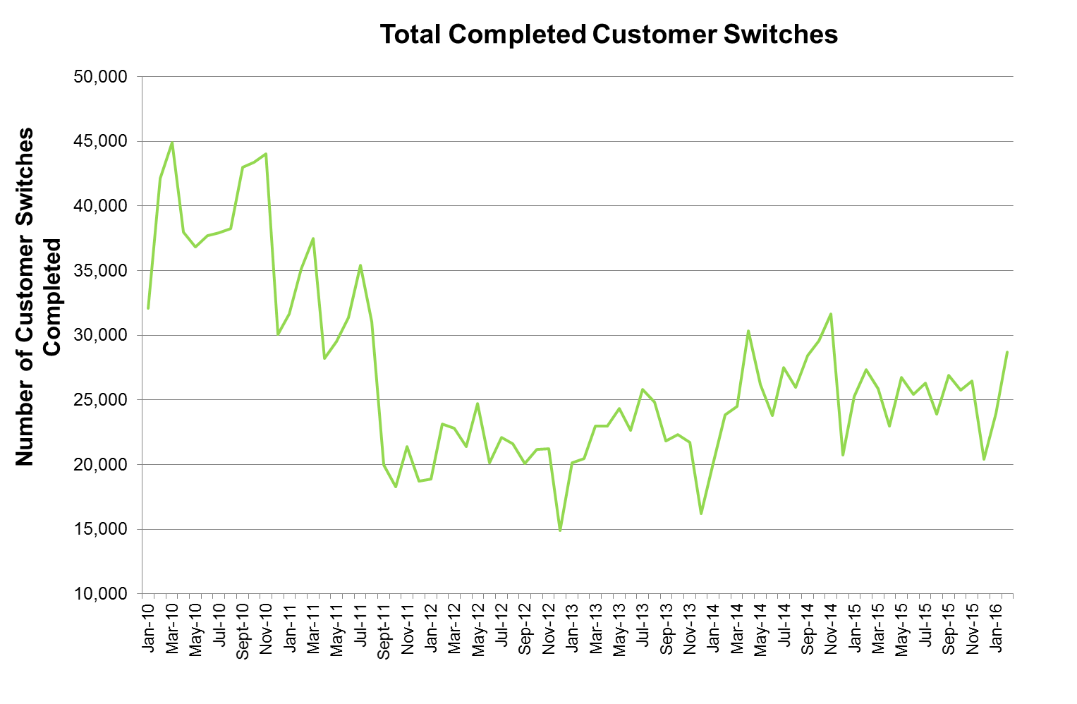
Figure 1. The total number of electricity customer switches completed per month from January 2010 to February 2016.

Figure 1 shows that for 2015, the highest number of switches occurred in February, with 27,347 switches in total. The average number of switches for 2014 was 26,040 while the average number of switches for 2015 was 25,226.
There were 28,684 switches in total in February 2016, rising from 23,925 switches in January 2016. This compares to a total of 27,347 switches in February 2015.

Suppliers’ Net Switching Position
Figures 2 and 3 present the net monthly switching positions per supplier. This net switching data considers the number of customers that have moved to and from each supplier and show a net position (if a supplier has lost more customers than it has gained than their net position will be a loss of customers and a negative figure will be presented and vice versa).
Figure 2 presents this data from January 2010 to February 2016 while Figure 3 presents the last 12 months of available data (February 2015 to February 2016).
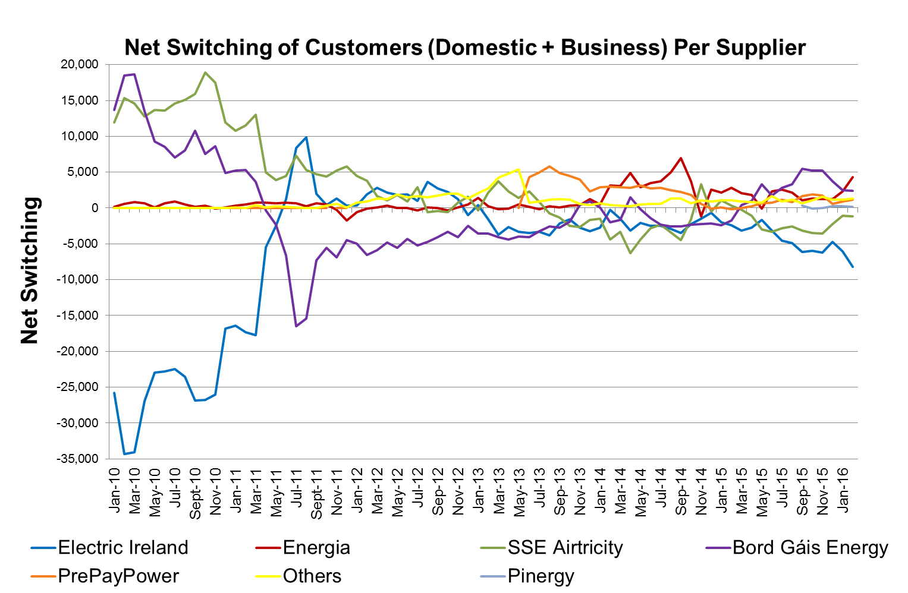
Figure 2. The net switching position of each electricity supplier from January 2010 to February 2016, for domestic and business customers.

Figure 3. The net switching position of each electricity supplier from February 2015 to February 2016.

Figure 3 indicates that for the second part of 2015 and beginning of 2016 Electric Ireland had a net loss of customers Energia had a net gain of customers. The net switching position for all suppliers for February 2016 is presented below.

Electric Ireland | Energia | SSE Airtricity | Bord Gáis Energy | PrePayPower | Pinergy | Others
-8,203 | 4,337 | -1,133 | 2,407 | 1,120 | 142 | 1,330
Net switching for suppliers, February 2016
In the electricity sector, Electric Ireland and SSE Airtricity lost customers from the end of 2015 to the start of 2016, while Energia, Bord Gáis Energy, PrePayPower and Pinergy gained customers overall.

Suppliers’ Gains and Losses
Table 1 presents the number of customer losses per electricity supplier per month. Table 2 presents the number of customers each electricity supplier has gained per month – recall that this data like all other data in this report does not include new registrations.
Table 1. Monthly customer losses by electricity supplier.
 | Electric Ireland | Energia | SSE Airtricity | Bord Gáis Energy | PrePayPower | Pinergy | Others | Total
Jan-14 | 8,406 | 1,151 | 6,323 | 3,727 | 355 | - | 101 | 20,063
Feb-14 | 8,633 | 754 | 8,998 | 5,000 | 348 | - | 80 | 23,813
Mar-14 | 9,395 | 803 | 8,795 | 5,056 | 388 | - | 70 | 24,507
Apr-14 | 11,762 | 925 | 11,426 | 5,772 | 370 | - | 75 | 30,330
May-14 | 10,276 | 944 | 9,231 | 5,232 | 431 | - | 70 | 26,184
Jun-14 | 9,277 | 772 | 8,109 | 4,792 | 674 | - | 138 | 23,762
Jul-14 | 10,789 | 1,037 | 8,814 | 5,862 | 820 | - | 186 | 27,508
Aug-14 | 10,181 | 740 | 8,384 | 5,566 | 948 | - | 158 | 25,977
Sept-14 | 11,047 | 899 | 9,275 | 5,966 | 1,104 | - | 119 | 28,410
Oct-14 | 11,069 | 1,997 | 8,887 | 6,168 | 1,234 | - | 224 | 29,579
Nov-14 | 10,384 | 5,148 | 8,305 | 5,918 | 1,686 | - | 191 | 31,632
Dec-14 | 7,387 | 1,045 | 6,106 | 4,505 | 1,503 | - | 169 | 20,715
Jan-15 | 9,637 | 1,499 | 6,838 | 5,325 | 1,738 | - | 231 | 25,268
Feb-15 | 10,274 | 1,841 | 7,732 | 5,253 | 1,955 | - | 292 | 27,347
Mar-15 | 10,346 | 1,924 | 7,202 | 4,340 | 1,694 | - | 327 | 25,833
Apr-15 | 9,002 | 2,038 | 6,349 | 3,708 | 1,495 | - | 352 | 22,944
May-15 | 9,462 | 4,364 | 7,243 | 3,596 | 1,573 | - | 474 | 26,712
Jun-15 | 9,476 | 3,207 | 7,017 | 3,865 | 1,301 | - | 538 | 25,404
Jul-15 | 10,396 | 2,678 | 7,362 | 3,686 | 1,406 | - | 779 | 26,307
Aug-15 | 9,548 | 2,501 | 6,614 | 3,204 | 1,325 | - | 675 | 23,867
Sep-15 | 10,884 | 3,063 | 7,272 | 3,321 | 1,395 | 952 | 19 | 26,906
Oct-15 | 10,259 | 3,210 | 6,888 | 3,104 | 1,268 | 1000 | 36 | 25,765
Nov-15 | 10,483 | 3,323 | 7,192 | 3,161 | 1,308 | 941 | 47 | 26,455
Dec-15 | 8,312 | 2,581 | 5,344 | 2,372 | 1,172 | 558 | 40 | 20,379
Jan-16 | 10,024 | 2,982 | 5,951 | 3,283 | 1,073 | 541 | 71 | 23,925
Feb-16 | 12,282 | 3,471 | 7,125 | 3,810 | 1,259 | 653 | 84 | 28,684

Table 2. Monthly customer gains by electricity supplier.
 | Electric Ireland | Energia | SSE Airtricity | Bord Gáis Energy | PrePayPower | Pinergy | Others | Total
Jan-14 | 5,704 | 1,654 | 4,864 | 3,770 | 3,284 | - | 787 | 20,063
Feb-14 | 8,391 | 3,922 | 4,597 | 3,012 | 3,361 | - | 530 | 23,813
Mar-14 | 7,912 | 3,909 | 5,519 | 3,436 | 3,323 | - | 408 | 24,507
Apr-14 | 8,632 | 5,854 | 5,103 | 7,246 | 3,156 | - | 339 | 30,330
May-14 | 8,236 | 3,825 | 4,860 | 5,066 | 3,596 | - | 601 | 26,184
Jun-14 | 6,793 | 4,246 | 5,298 | 3,358 | 3,378 | - | 689 | 23,762
Jul-14 | 8,314 | 4,803 | 6,533 | 3,513 | 3,608 | - | 737 | 27,508
Aug-14 | 7,290 | 5,742 | 5,022 | 2,977 | 3,460 | - | 1,486 | 25,977
Sept-14 | 7,601 | 7,837 | 4,784 | 3,426 | 3,347 | - | 1,415 | 28,410
Oct-14 | 8,864 | 5,694 | 7,301 | 3,822 | 3,033 | - | 866 | 29,580
Nov-14 | 8,881 | 3,989 | 11,618 | 3,662 | 2,249 | - | 1,233 | 31,632
Dec-14 | 6,709 | 3,595 | 5,597 | 2,334 | 1,382 | - | 1,098 | 20,715
Jan-15 | 7,616 | 3,688 | 7,888 | 2,958 | 1,842 | - | 1,276 | 25,268
Feb-15 | 7,896 | 4,683 | 8,032 | 3,527 | 1,824 | - | 1,385 | 27,347
Mar-15 | 7,225 | 3,966 | 6,914 | 4,768 | 1,732 | - | 1,228 | 25,833
Apr-15 | 6,263 | 3,842 | 5,265 | 4,694 | 1,728 | - | 1,152 | 22,944
May-15 | 7,791 | 4,293 | 4,219 | 6,947 | 2,207 | - | 1,253 | 26,710
Jun-15 | 6,352 | 5,493 | 3,726 | 5,630 | 2,014 | - | 2,191 | 25,406
Jul-15 | 5,810 | 5,240 | 4,541 | 6,471 | 2,538 | - | 1,707 | 26,307
Aug-15 | 4,641 | 4,665 | 4,084 | 6,541 | 2,125 | - | 1,811 | 23,867
Sep-15 | 4,753 | 4,158 | 4,154 | 8,798 | 3,059 | 1,282 | 702 | 26,906
Oct-15 | 4,322 | 4,519 | 3,421 | 8,284 | 3,174 | 901 | 1,144 | 25,765
Nov-15 | 4,252 | 4,594 | 3,601 | 8,356 | 3,080 | 937 | 1,635 | 26,455
Dec-15 | 3,592 | 3,799 | 3,109 | 6,080 | 1,781 | 807 | 1,211 | 20,379
Jan-16 | 3,973 | 5,316 | 4,892 | 5,751 | 2,007 | 784 | 1,202 | 23,925
Feb-16 | 4,079 | 7,808 | 5,992 | 6,217 | 2,379 | 795 | 1,414 | 28,684

Customer Switching in the Gas Retail Markets
This section provides monthly data for the gas retail markets from January 2010 to February 2016 and includes:
- Total completed switches
- Suppliers’ net switching position (shows whether or not a supplier is winning more customers than it is losing in a given month)
- The number of customers switching to each supplier
- The number of customers moving away from each supplier
The data includes all switches completed by domestic and business customers. The presented data excludes new registrations as these customers have not switched from one supplier to another. Where data is presented per supplier, only suppliers with a 1 % market share (on a consumption basis) or greater are presented.

Completed Gas Switches per Month
Figure 4 details the total number of completed switches in each month from January 2010 to February 2016.
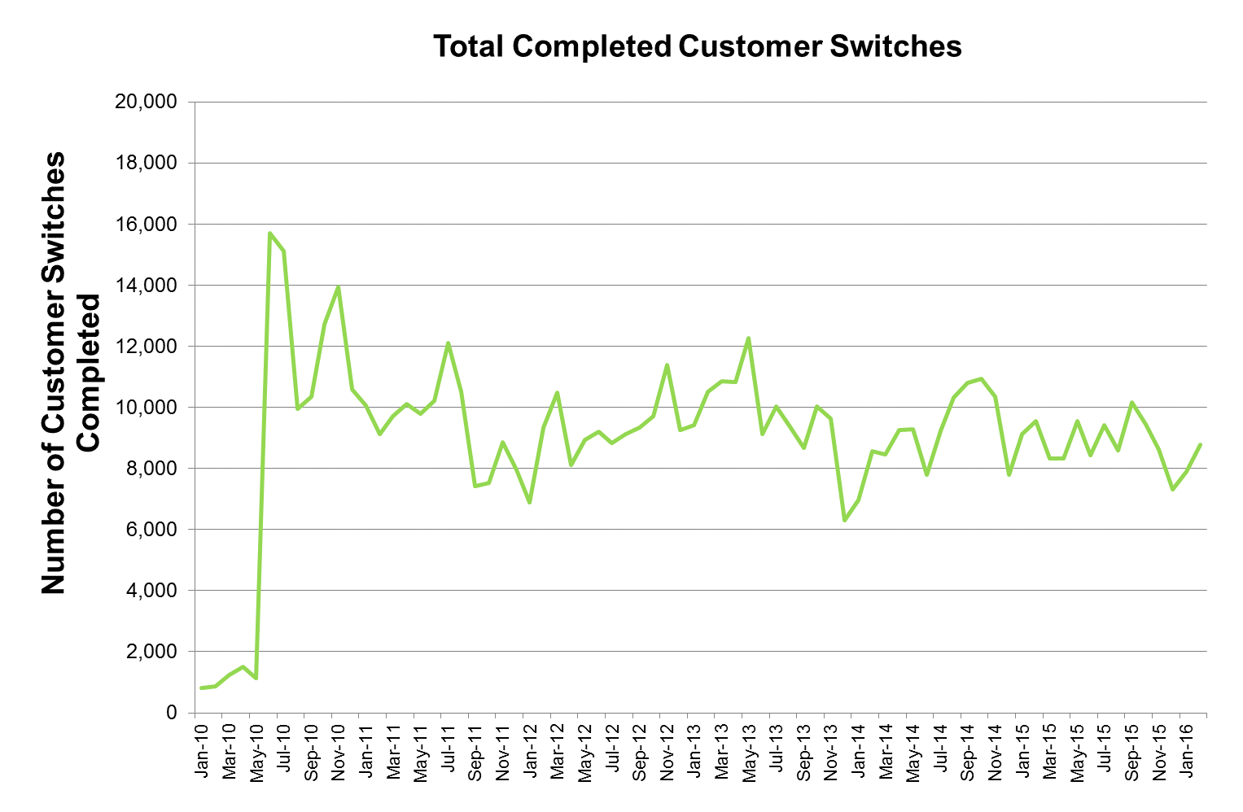
Figure 4. The total number of gas customer switches completed per month from January 2010 to February 2016.
The average number of switches per month between January 2010 and February 2016 was 9,028 with an average of 8,801 switches per month between February 2015 and February 2016. The highest rate of switching in 2015 was between September and October, with 10,174 switches, as shown in Figure 4. There were a total of 8,766 switches in February 2016.

Suppliers’ Net Switching Position
Figures 5 and 6 present the net monthly switching positions per gas supplier. These net switching data consider the number of customers that have moved to and from each supplier and present a net position (if a supplier has lost more customers than it has gained than their net position will be a loss of customers and a negative figure will be presented and vice versa). Figure 5 presents these data from January 2010 to February 2016 while figure 6 presents the last 12 months of available data (February 2015 to February 2016).
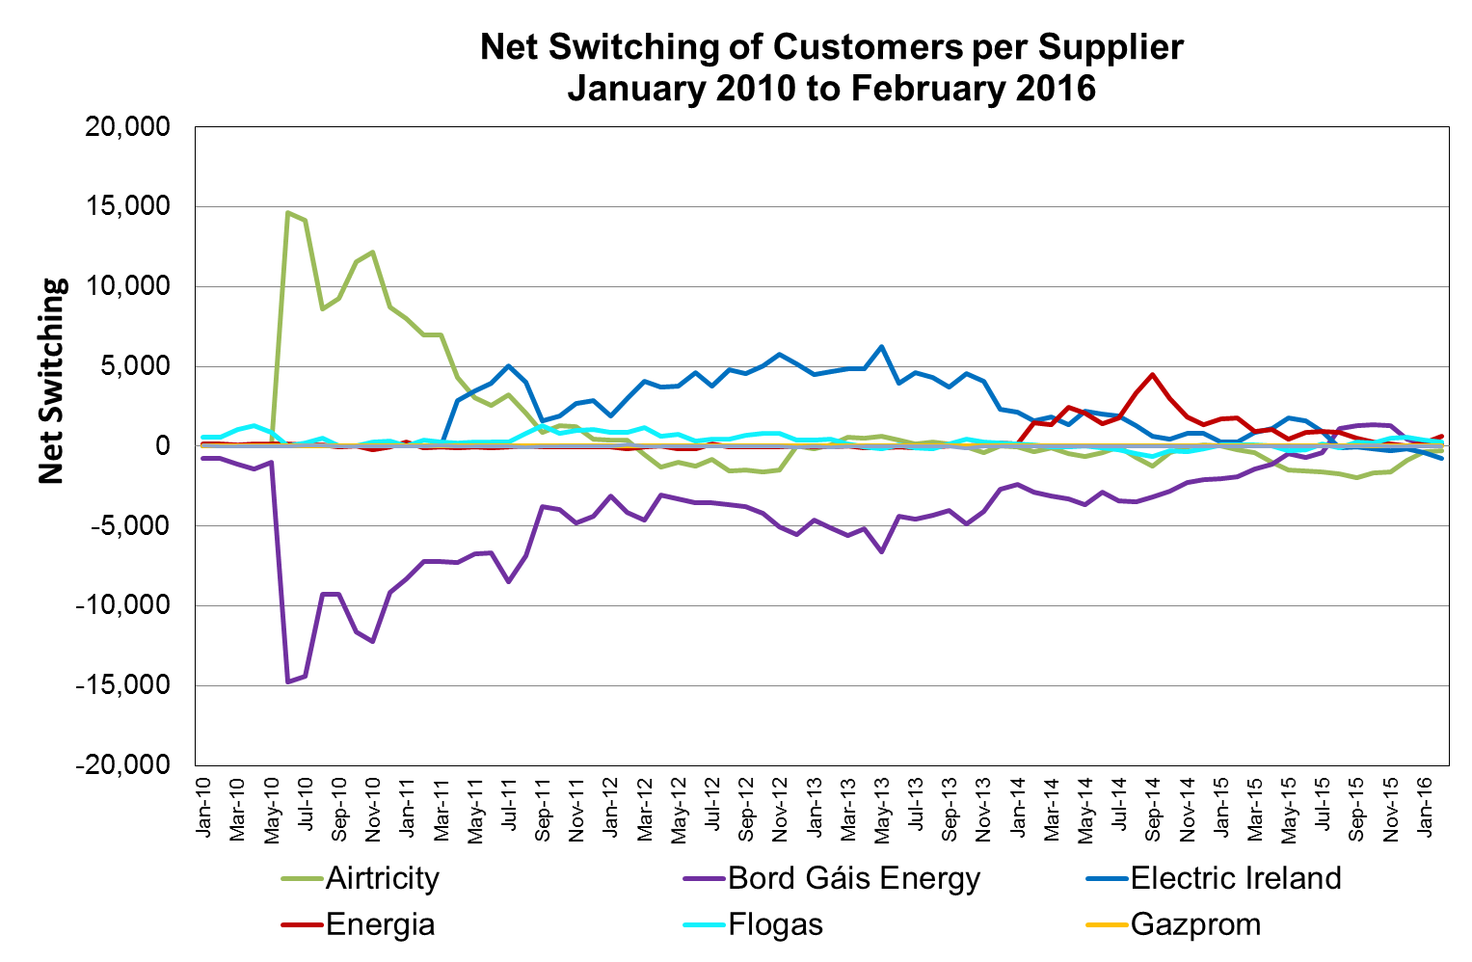
Figure 5. The net switching position of each gas supplier from January 2010 to February 2016, for domestic and business customers.
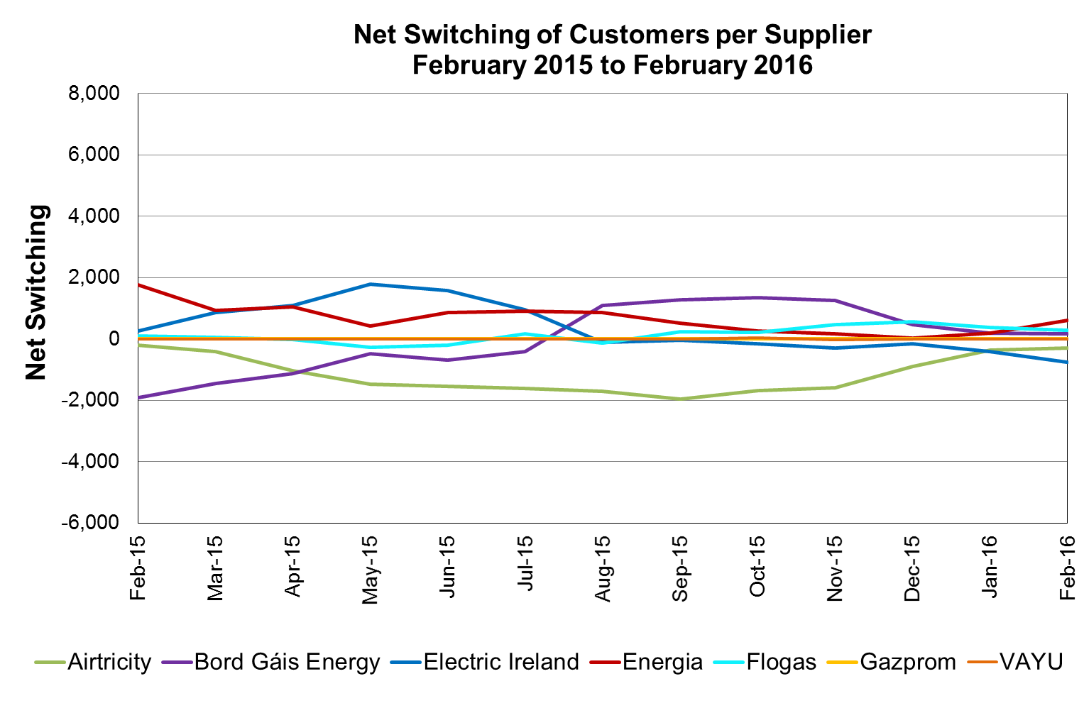
Figure 6. The net switching position of each gas supplier from January 2015 to February 2016.

Airtricity | Bord Gáis Energy | Electric Ireland | Energia | Flogas | Gazprom | VAYU
-289 | 157 | -753 | 608 | 276 | 0 | 1
Net switching for suppliers, February 2016
In the gas sector, Electric Ireland, SSE Airtricity lost customers in February 2016, while Bord Gáis Energy, Energia and Flogas gained customers overall.

Suppliers’ Gains and Losses
Table 3 presents the number of customer losses per gas supplier per month. Table 4 presents the number of customers each gas supplier has gained per month – recall that these data like all other data in this report do not include new registrations.
Table 3. Monthly customer losses by gas supplier.
 | Airtricity | Bord Gáis Energy | Electric Ireland | Energia | Flogas | Gazprom | VAYU | Total
Jan-14 | 1,776 | 3,027 | 1,393 | 57 | 724 | - | 2 | 6,979
Feb-14 | 2,215 | 3,574 | 1,830 | 79 | 863 | - | - | 8,561
Mar-14 | 2,174 | 3,736 | 1,679 | 56 | 810 | - | 2 | 8,457
Apr-14 | 2,435 | 3,905 | 1,853 | 117 | 947 | - | 3 | 9,260
May-14 | 2,460 | 4,319 | 1,614 | 81 | 810 | - | 2 | 9,286
Jun-14 | 1,991 | 3,516 | 1,407 | 96 | 723 | - | 51 | 7,784
Jul-14 | 2,245 | 4,145 | 1,892 | 101 | 845 | - | 3 | 9,231
Aug-14 | 2,660 | 4,319 | 2,314 | 110 | 925 | - | 5 | 10,333
Sept-14 | 2,860 | 4,324 | 2,412 | 113 | 1,090 | - | - | 10,799
Oct-14 | 2,584 | 4,308 | 2,793 | 171 | 1,032 | 2 | 46 | 10,936
Nov-14 | 2,421 | 4,109 | 2,518 | 245 | 1,041 | - | 2 | 10,336
Dec-14 | 1,731 | 3,245 | 1,864 | 138 | 806 | - | 4 | 7,788
Jan-15 | 2,155 | 3,419 | 2,385 | 216 | 934 | 5 | 1 | 9,115
Feb-15 | 2,316 | 3,410 | 2,460 | 355 | 1,000 | - | 1 | 9,542
Mar-15 | 2,153 | 2,983 | 1,930 | 455 | 801 | - | 1 | 8,323
Apr-15 | 2,416 | 2,828 | 1,785 | 523 | 759 | 1 | 2 | 8,314
May-15 | 2,602 | 3,046 | 1,924 | 775 | 1,161 | - | 53 | 9,561
Jun-15 | 2,447 | 2,860 | 1,693 | 596 | 834 | - | 2 | 8,432
Jul-15 | 2,628 | 3,011 | 2,101 | 843 | 830 | - | 2 | 9,415
Aug-15 | 2,522 | 2,101 | 2,229 | 902 | 847 | - | 1 | 8,602
Sep-15 | 2,812 | 2,582 | 2,440 | 1,424 | 906 | - | 10 | 10,174
Oct-15 | 2,588 | 2,225 | 2,259 | 1,364 | 944 | - | 60 | 9,440
Nov-15 | 2,364 | 2,025 | 2,091 | 1,302 | 817 | 1 | 30 | 8,630
Dec-15 | 1,875 | 1,878 | 1,741 | 1139 | 677 | - | 4 | 7,314
Jan-16 | 1,866 | 2,070 | 2,009 | 1239 | 706 | 2 | 8 | 7,900
Feb-16 | 2,059 | 2,187 | 2,317 | 1,341 | 861 | - | 1 | 8,766

Table 4. Monthly customer gains by gas supplier.
 | Airtricity | Bord Gáis Energy | Electric Ireland | Energia | Flogas | Gazprom | VAYU | Total
Jan-14 | 1,760 | 646 | 3,540 | 171 | 860 | - | 2 | 6,979
Feb-14 | 1,865 | 721 | 3,452 | 1,567 | 956 | - | - | 8,561
Mar-14 | 2,101 | 645 | 3,535 | 1,426 | 747 | - | 3 | 8,457
Apr-14 | 1,966 | 596 | 3,207 | 2,553 | 934 | 1 | 3 | 9,260
May-14 | 1,837 | 631 | 3,815 | 2,173 | 829 | - | 1 | 9,286
Jun-14 | 1,562 | 646 | 3,402 | 1,502 | 626 | - | 46 | 7,784
Jul-14 | 2,189 | 747 | 3,797 | 1,892 | 604 | - | 2 | 9,231
Aug-14 | 1,954 | 866 | 3,591 | 3,471 | 447 | - | 4 | 10,333
Sept-14 | 1,613 | 1,141 | 3,042 | 4,576 | 426 | - | 1 | 10,799
Oct-14 | 2,212 | 1,491 | 3,245 | 3,166 | 782 | - | 40 | 10,936
Nov-14 | 2,397 | 1,837 | 3,337 | 2,054 | 709 | - | 2 | 10,336
Dec-14 | 1,831 | 1,130 | 2,687 | 1,500 | 637 | - | 3 | 7,788
Jan-15 | 2,170 | 1,368 | 2,636 | 1,917 | 1,022 | - | 2 | 9,115
Feb-15 | 2,122 | 1,490 | 2,711 | 2,117 | 1,101 | - | 1 | 9,542
Mar-15 | 1,740 | 1,528 | 2,800 | 1,388 | 864 | - | 3 | 8,323
Apr-15 | 1,385 | 1,711 | 2,889 | 1,575 | 753 | - | 1 | 8,314
May-15 | 1,135 | 2,576 | 3,709 | 1,206 | 891 | - | 44 | 9,561
Jun-15 | 908 | 2,172 | 3,260 | 1,462 | 630 | - | - | 8,432
Jul-15 | 1,024 | 2,604 | 3,045 | 1,748 | 994 | - | - | 9,415
Aug-15 | 815 | 3,188 | 2,113 | 1,762 | 723 | - | 1 | 8,602
Sep-15 | 845 | 3,849 | 2,396 | 1,932 | 1,149 | - | 3 | 10,174
Oct-15 | 898 | 3,566 | 2,102 | 1,627 | 1,158 | - | 89 | 9,440
Nov-15 | 782 | 3,289 | 1,789 | 1,474 | 1,296 | - | - | 8,630
Dec-15 | 970 | 2,352 | 1,585 | 1,158 | 1,242 | - | 7 | 7,314
Jan-16 | 1,508 | 2,267 | 1,601 | 1,432 | 1,084 | - | 8 | 7,900
Feb-16 | 1,770 | 2,344 | 1,564 | 1,949 | 1,137 | - | 2 | 8,766

